1. 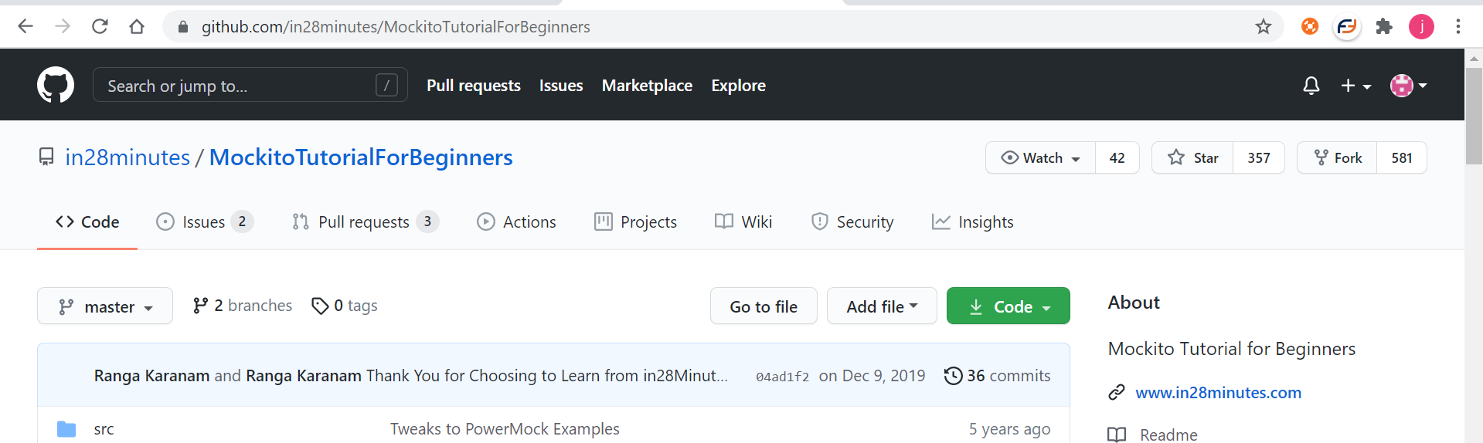
2. <https://github.com/in28minutes/MockitoTutorialForBeginners>
3. 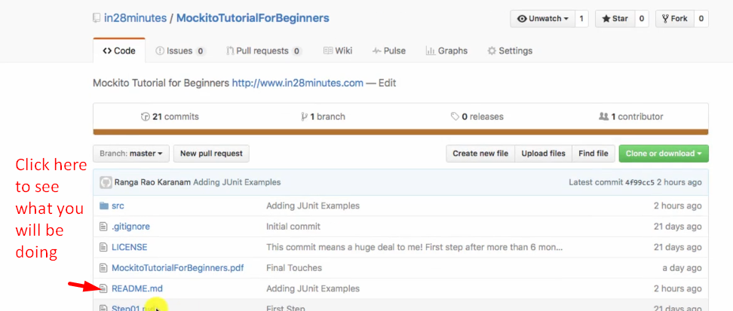
4. 